

SERPRO POC1 Test Cases

Version 1.0
Date 28/09/2026

Table of Contents
1 Test cases Description 4
1.1 Objective 4
1.2 Test Scope 4
1.3 Preconditions and Preparations 5
1.4 Acceptance Method 5
2 Platform Architecture and Operation 6
2.1 Creating a DataArts Studio Instance 6
3 Data access, integration, and engineering 7
3.1 Creating an MRS Hive Link 7
3.2 Creating a Job for Migrating a Table from MRS Hive to OBS 8
3.3 Creating a Hive Connection 10
3.4 Creating a Spark Connection 11
3.5 Developing a Hive Script 13
3.6 Developing a Spark Script 14
3.7 Developing a Python Script 15
3.8 Running a CDM Job 16
3.9 Running an MRS Hive SQL Job 17
3.10 Creating Batch and Real-Time Processing Jobs 17
3.11 Executing a Job 18
3.12 Graphically Displaying Job Dependencies 19
3.13 Creating an MRS Connection 19
3.14 Editing a Data Connection 20
4 Metadata, catalog, modeling, and lineage 21
4.1 Creating and Running a Collection Task 21
4.2 Viewing Collected Metadata 22
4.3 Generating a Lineage 23
4.4 Creating a Data Warehouse Layer and a Model 25
4.5 Creating, Publishing, Exporting, Deleting, and Importing a Fact Table 26
4.6 Synchronizing Data Collected in DataArts Catalog to Data Map 28
5 Governance and Security 29
5.1 Creating a Data Catalog Permission 29
5.2 Configuring the Data Security Administrator 30
5.3 Creating a Sensitive Data Discovery Task 31
5.4 Creating a Static Masking Policy 32
5.5 Creating a Data Watermark Embedding Task 33
6 Data Quality and Observability 34
6.1 Creating a Custom Rule Template 34
6.2 Creating a One-Shot Quality Job 35
6.3 Creating a Periodic Quality Job 36
6.4 Performing O&M Operations 37
6.5 Verifying a Quality Report 38
7 Data sharing and data services 38
7.1 Developing a GUI-based API 38
7.2 Developing a Script API 40
7.3 Calling APIs 41
7.4 Exporting and Importing APIs 42
7.5 Editing an API 42
7.6 Filtering APIs by Authorization Status 44
7.7 Exporting and Importing APIs with Tags 45
8 DataOps and Lifecycle Management 45
8.1 Testing a Job 45
8.2 Creating, Exporting, Deleting, and Importing a Process 46
8.3 Creating a Data Source Export Task 48
9 Resilience, Monitoring, and Resource Consumption 49
9.1 Creating a cdm.xlarge Incremental Package 49
9.2 Viewing Monitoring Metrics of a Cluster 51
9.3 Viewing Monitoring Overview 51
9.4 Monitoring Real-Time Processing Jobs 52
9.5 Monitoring Instances 52

Test cases Description

Objective
In an environment representative of Huawei's solutions, the core capabilities of the Unified Data Platform (PUD) are to be validated, with a particular focus on actual execution and observable evidence. The acceptance should demonstrate the integrated operation of HCS and DataArts Studio, from data ingestion to data consumption, especially covering data engineering, governance, security, quality, observability, and controlled data sharing.

Test Scope
Domain | What Should Be Observed
Platform Architecture and Operation | HCS/DataArts topology, components, isolation, local operation, management, and external dependencies.
Data Access, Integration, and Engineering | Batch loading, replication/CDC or equivalent capabilities, streaming processing where applicable, transformation, orchestration, dependencies, and reprocessing.
Metadata, Catalogs, Modeling, and Lineage | Discovery, cataloging, glossaries, attribution, classification, modeling, and traceability between source, transformation, and consumption.
Governance and Security | Identity and roles, fine-grained authorization, sensitive data protection, desensitization, anonymization, auditing, and isolation.
Data Quality and Observability | Analysis, indicators, service rules, alarms, troubleshooting, indicator system, and pipeline and data monitoring.
Data Sharing and Data Services | Controlled release of APIs/services, access management, revocation, auditing, and application consumption.
DataOps and Lifecycle | Version management, parameterization, promotion between environments, automation, testing, and traceability of changes.
Resilience, Monitoring, and Resource Consumption | Operational indicators, usage by workload/tenant, backup/recovery, and evidence of high availability (if applicable).

Preconditions and Preparations
• The HCS/DataArts environment should be pre-installed, accessible, and stable. All modules involved in the solution must be available for testing.
• Prepare a representative dataset, prioritizing the use of electronic tax documents or equivalent data volumes. If necessary, desensitization and anonymization should be completed in advance.
• At least one relational data source and one file/object storage repository shall be provided for testing access and transformation. If streaming or CDC falls within the scope of acceptance, the corresponding data sources shall also be provided.
• Different user roles shall be provided to test management, data engineering, data catalog/governance, and data consumption.
• Access to the management interface, logs, metrics, audit trails, and configuration evidence required for attestation shall be provided.
• Huawei shall provide prior notice of any dependencies on components, additional licenses, or uninstalled and un-integrated functions outside the acceptance environment.
• All tests shall produce objective evidence: screenshots, logs, configurations, query results, exports, reports, or reproducible demonstrations.

Acceptance Method
Each module should be evaluated in combination with a brief demonstration, practical operation, and evidence retention. The recommended evaluation criteria are as follows:
Result | Explanation
Satisfied | The function has been executed in the acceptance environment and is supported by evidence, with no significant limitations.
Satisfied but with reservations | The function has been demonstrated, but there are limitations, dependencies, additional configurations, or constraints that need to be documented.
Not satisfied | The function has not been executed, demonstrated, or is incompatible with the required behavior.
Untested | Does not meet the conditions for execution; the reasons must be provided along with a subsequent proof plan.

Platform Architecture and Operation

Creating a DataArts Studio Instance
Objective | Verify that a DataArts Studio instance can be created.
Prerequisites | - DataArts Studio is running properly.  - You have created a VPC, subnet, and security group.
Procedure | - On the DataArts Studio home page, click Create Instance.  - Configure the parameters as follows:  - Select a region as required for Region.  - Enterprise Project: An enterprise project can contain only one DataArts Studio instance. To create more instances, create more enterprise projects first. To enable a DataArts Studio instance to communicate with other cloud services, ensure that the instance's enterprise project is the same as those of other cloud services.  - Set a version as required for Version. (Basic version instances do not support data governance.)  - You can customize an instance name in Instance Name or use the default value.  - After obtaining the DataArts Studio instance, click Access under the instance. Click the Workspaces tab, locate the default workspace, and click Edit in the Operation column.  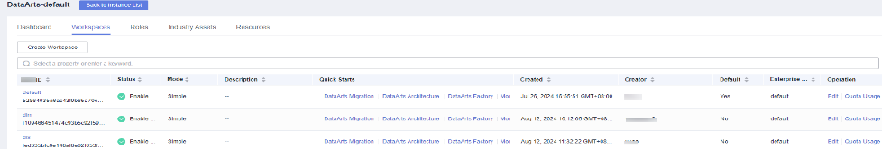  - In the displayed Workspace Information dialog box, add a workspace member:  Select a test user for Member Account.  Select admin for Role.  Click Yes.  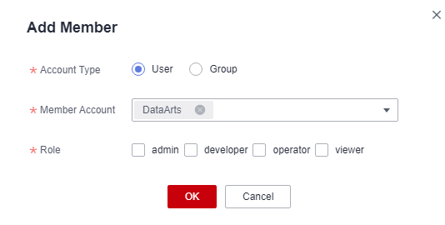  - Click x in the upper right corner to close the window.
Expected Result | - The DataArts Studio instance is created.  - The member is added.
Remarks
Test Result

Data access, integration, and engineering

Creating an MRS Hive Link
Objective | Verify that an MRS Hive link can be created.
Prerequisites | - The security administrator (user) has registered an account and can log in to the DataArts Studio console and access DataArts Migration.  - The CDM service is running properly.  - A CDM cluster has been created.  - The MRS cluster contains Hive. The username and password of the MRS cluster have been obtained.
Procedure | - Go to the Cluster Management page and locate a running cluster.  - Click Job Management. On the displayed page, click the Links tab.  - Click Create Link, select MRS Hive, and check whether the Create Link page is displayed.  - Set parameters such as Name, Manager IP, Username, and Password.  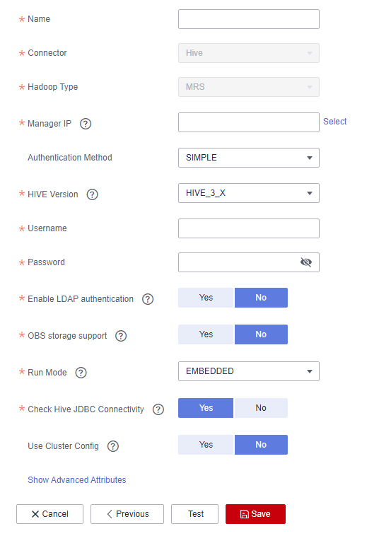  - Click Test to test the connectivity.  - Click Save and check whether the settings are saved successfully.
Expected Result | - The Cluster Management page and the Job Management page are displayed properly.  - The Links page is displayed properly.  - The Create Link page is displayed.  - The parameters are set successfully.  - The test is successful.  - The settings are saved successfully.
Remarks | Test duration: 5 minutes
Test Result | N/A

Creating a Job for Migrating a Table from MRS Hive to OBS
Objective | Verify that a job can be created for migrating a table from MRS Hive to OBS.
Prerequisites | - The security administrator (user) can log in to the DataArts Studio console and access DataArts Migration.  - The CDM service is running properly.  - You have created a cluster.  - An MRS Hive link and an OBS link have been created.
Procedure | - Go to the Cluster Management page and click Job Management.  - Click Table File Migration and click Create Job to create a migration job.  - Enter a job name.  - Select an MRS Hive link for Source Link Name and select the database where the table to be migrated is located for Database Name.  - Set Table Name to the name of the table to be migrated.  - Select an OBS link for Destination Link Name and select the bucket to which the table will be migrated for Bucket Name.  - Set Write Directory to the path to which the table will be migrated.  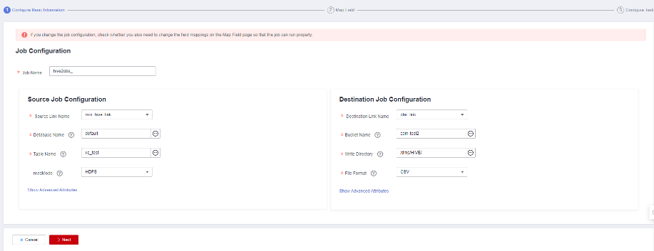  - Click Next.  - Click Next.  - Click Save and Execute.  - Return to the job list and check whether the job is successfully executed.
Expected Result | - The Job Management page is displayed.  - The Create Job page is displayed.  - The job name is successfully entered.  - Source Link Name and Database Name are set successfully.  - Table Name is set successfully.  - Destination Link Name and Bucket Name are set successfully.  - Write Directory is set successfully.  - The Map Field page is displayed.  - The Configure Task page is displayed.  - The operation is successful.  - The job is successfully executed.
Remarks | Test duration: 15 minutes
Test Result | N/A

Creating a Hive Connection
Objective | Verify that a Hive connection can be created.
Prerequisites | - The data development function is normal.  - You have created MRS and CDM clusters that contain the Hive component.
Procedure | - Log in to DataArts Studio console. Click the Workspaces tab. Locate one of the workspaces in the workspace list, and click More in the Quick Entry column, select Management Center.  - Click Create Data Connection, set Data Connection Type to MRS Hive, and set the parameters as follows:  Data Connection Name: Enter hive. You can customize a name.  Description: empty (The description of a Hive connection can be empty.)  Tag: attribute of the data connection to create. Tags make management easier.  Applicable Modules: Select the modules to which the connection applies. The connection can be used in the selected modules.  Set Connection Type to Proxy connection. A CDM cluster is required for proxy connection. If Connection Type is set to MRS API connection, Agent, Username, and Password are not displayed.  Manual: Cluster Name Mode is selected by default. In this case, select an existing cluster name. If you select Connection String Mode, you need to set Manager IP and ensure that the Agent (CDM cluster) of the connection can communicate with the MRS cluster.  MRS Cluster Name: Set it to MRS_dlf. You can create an MRS cluster on the MRS console.  Manager IP: Enter the floating IP address of MRS Manager. Only the MRS cloud service can be connected. This parameter is required when Manual is set to Connection String Mode.  Agent: Set it to cdm_dlf, a CDM cluster name. You can create a CDM cluster on the CDM console. The MRS and CDM clusters must be in the same VPC, subnet, and security group. Otherwise, the connection fails to be created.  Authentication Method: Select SIMPLE for the non-security mode and KERBEROS for the security mode. This parameter is required when Manual is set to Connection String Mode.  Set Username to admin, which is the username configured during the creation of the MRS cluster. If the MRS cluster is in security mode, you need to log in to the MRS cluster management page to create a user. For details about how to create a user, see "FusionInsight Manager Operation Guide" > "System" > "Configuring Permissions" > "Managing Users" > "Creating a User" in MapReduce Service User Guide.  Password: Set it to that configured during the creation of the MRS cluster user.  Enable ldap: Retain the default disabled state. This parameter is available when Connection Type is set to Proxy connection. If LDAP authentication is enabled for an external LDAP server connected to MRS Hive, the LDAP username and password are required for authenticating the connection to MRS Hive. In this case, this option must be enabled. Otherwise, the connection will fail.  ldapUsername: This parameter is mandatory when Enable ldap is enabled. Enter the username configured when LDAP authentication was enabled for MRS Hive.  ldapPassword: This parameter is mandatory when Enable ldap is enabled. Enter the password configured when LDAP authentication was enabled for MRS Hive.  Real-time Metadata Synchronization: It is disabled by default. (If it is enabled, the metadata of the connected MRS cluster is synchronized to the Data Map module in real time.)  jobGateway IP: This parameter is displayed when Connection Type is set to MRS tenant plane connection. Enter two IP address of the JobBalancer role of the jobGateway component and separate them with a comma (,).  MRS Authentication Type: This parameter is displayed when Connection Type is set to MRS tenant plane connection. The default value is iam.  Keytab File: This parameter is displayed when Connection Type is set to MRS tenant plane connection and MRS Authentication Type is set to keytab. Upload the authentication credential downloaded by the user of the MRS cluster.)  - Click Test to test the connectivity.  - Click Save.  - Go to the DataArts Factory console, choose Data Connections > Connection, and check whether the Hive connection has been synchronized.
Expected Result | The MRS Hive connection is created and synchronized.
Remarks | N/A
Test Result | N/A

Creating a Spark Connection
Objective | Verify that an MRS Spark connection can be created.
Prerequisites | - The data development function is normal.  - You have created MRS and CDM clusters that contain the Spark component.
Procedure | - Log in to DataArts Studio console. Click the Workspaces tab. Locate one of the workspaces in the workspace list, and click More in the Quick Entry column, select Management Center.  - Click Create Data Connection, set Data Connection Type to MRS Spark, and set the parameters as follows:  Data Connection Name: Enter sparksql. You can customize a name.  Description: empty (The description of a SparkSQL connection can be empty.)  Tag: attribute of the data connection to create. Tags make management easier.  Applicable Modules: Select the modules to which the connection applies. The connection can be used in the selected modules.  Set Connection Type to Proxy connection. A CDM cluster is required for proxy connection. If Connection Type is set to MRS API connection, Agent, Username, and Password are not displayed.  Manual: Cluster Name Mode is selected by default. In this case, select an existing cluster name. If you select Connection String Mode, you need to set Manager IP and ensure that the Agent (CDM cluster) of the connection can communicate with the MRS cluster.  MRS Cluster Name: Set it to MRS_dlf. You can create an MRS cluster on the MRS console.  Manager IP: Enter the floating IP address of MRS Manager. Only the MRS cloud service can be connected. This parameter is required when Manual is set to Connection String Mode.  Agent: Set it to cdm_dlf, a CDM cluster name. You can create a CDM cluster on the CDM console. The MRS and CDM clusters must be in the same VPC, subnet, and security group. Otherwise, the connection fails to be created.  Set Username to admin, which is the username configured during the creation of the MRS cluster. If the MRS cluster is in security mode, you need to log in to the MRS cluster management page to create a user. For details about how to create a user, see "FusionInsight Manager Operation Guide" > "System" > "Configuring Permissions" > "Managing Users" > "Creating a User" in MapReduce Service User Guide.  Password: Set it to that configured during the creation of the MRS cluster user.  jobGateway IP: This parameter is displayed when Connection Type is set to MRS tenant plane connection. Enter two IP address of the JobBalancer role of the jobGateway component and separate them with a comma (,).  MRS Authentication Type: This parameter is displayed when Connection Type is set to MRS tenant plane connection. The default value is iam.  Keytab File: This parameter is displayed when Connection Type is set to MRS tenant plane connection and MRS Authentication Type is set to keytab. Upload the authentication credential downloaded by the user of the MRS cluster.)  - Click Test to test the connectivity.  - Click Save.  - Go to the DataArts Factory console, choose Data Connections > Connection, and check whether the Spark connection has been synchronized.
Expected Result | The MSR Spark connection is created and synchronized.
Remarks | N/A
Test Result | N/A

Developing a Hive Script
Objective | Verify that a Hive script can be developed.
Prerequisites | The data development function is normal, and a Hive connection is available.
Procedure | - On the DataArts Factory page, choose Data Development > Develop Script.  - Right-click the script root directory and select Create Hive SQL Script. On the displayed page, enter the following content:  --Table creation  create table IF NOT EXISTS hive_test_${time}(id string, name string, score string);  --Insertion  insert into hive_test_${time} values('001','Tom','95.0'), ('002','test', '85.0');  --Query  select * from hive_test_${time};  --Renaming  alter table hive_test_${time} rename to backup_tbl_hive;  --Table deletion  drop table IF EXISTS backup_tbl_hive;  - Click Test Parameters and set the value for parameter time.  - Specify Connection and Database, and click Execute.  - Click Save, enter the script name hive_sql, and click OK. Then, click Submit. In the displayed Submit New Version dialog box, enter a version description, select The latest version and the current user who submits the version will be used in the next scheduling cycle. Are you sure you want to continue?, and click OK.  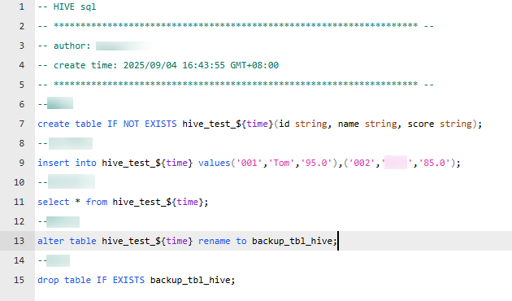  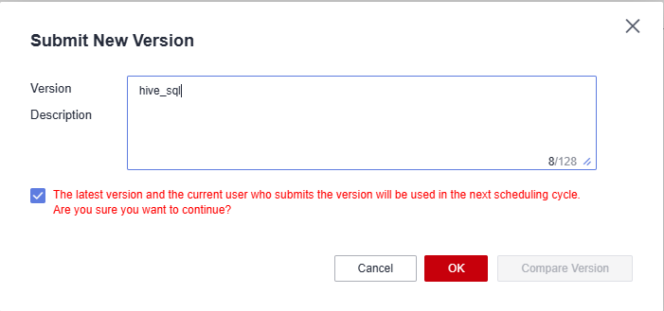
Expected Result | - The Hive script is executed.  - The script is saved and the version is submitted.
Remarks | N/A
Test Result | N/A

Developing a Spark Script
Objective | Verify that a Spark script can be developed.
Prerequisites | The data development function is normal, and a Spark connection is available.
Procedure | - On the DataArts Factory page, choose Data Development > Develop Script.  - Right-click the script root directory and select Create Spark SQL Script. On the displayed page, enter the following content:  --Table creation  create table IF NOT EXISTS spark_test_${time}(id string, name string, score string);  --Insertion  insert into spark_test_${time} values('001','Tom','95.0'),('002','test','85.0');  --Query  select * from spark_test_${time};  --Renaming  alter table spark_test_${time} rename to backup_tbl_spark;  --Table deletion  drop table IF EXISTS backup_tbl_spark;  - Click Test Parameter and set the value for parameter time.  - Specify Connection and Database, and click Execute.  - Click Save, enter the script name spark_sql, and click OK. Then, click Submit. In the displayed Submit New Version dialog box, enter a version description, select The latest version and the current user who submits the version will be used in the next scheduling cycle. Are you sure you want to continue?, and click OK.  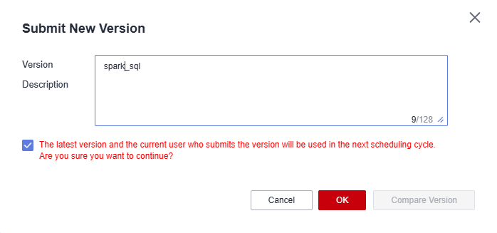
Expected Result | - The Spark script is executed.  - The script is saved and the version is submitted.
Remarks | N/A
Test Result | N/A

Developing a Python Script
Objective | Verify that a Python script can be developed.
Prerequisites | The data development function is normal, and a host connection is available.
Procedure | - On the DataArts Factory page, choose Data Development > Develop Script.  - Click + to create a Python script. Enter the following content:  print ("hello world")  - Set Python Version to Python 2, set Host Connection, and click Execute.  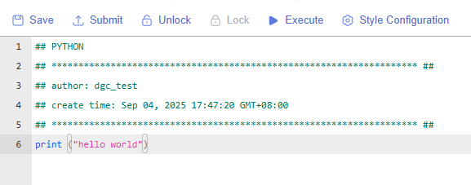  - Click Save, enter the script name python_scripts, and click OK. Then, click Submit. In the displayed Submit New Version dialog box, enter a version description, select The latest version and the current user who submits the version will be used in the next scheduling cycle. Are you sure you want to continue?, and click OK.
Expected Result | - The Python script is executed.  - The script is saved and the version is submitted.
Remarks | N/A
Test Result | N/A

Running a CDM Job
Objective | Verify that a CDM job can be executed.
Prerequisites | - DataArts Factory and CDM are running properly.  - A CDM cluster and a CDM job have been created.  - A batch processing job has been created.
Procedure | - Choose Data Development > Develop Job.  - In the job directory, double-click a batch processing job.  - Drag a CDM Job node to the canvas, and set the parameter as follows:  - Set Node Name to cdm_test. A value is automatically generated when you select a CDM job, and you can also customize a node name.  - Set CDM Cluster Name to the CDM cluster to which the CDM job to execute belongs.  - Set Job Type to Existing jobs.  - Set CDM job name. It specifies the CDM job to execute. The job is created on the Manage Job page of the CDM cluster.  - Click Save and Submit. In the displayed dialog box, enter the version description and click OK. Then click Execute. After the job is executed, go to the Monitor Job page and view the execution result.
Expected Result | The CDM job is executed.
Remarks | N/A
Test Result | N/A

Running an MRS Hive SQL Job
Objective | Verify that an MRS HIVE SQL job can be executed.
Prerequisites | The data development function and the MRS service are normal.
Procedure | - Choose Data Development > Develop Job.  - In the job directory, double-click a batch processing job.  - Drag an MRS Hive SQL node to the canvas, and set the parameter as follows:  - Set SQL script to hive_sql. The script to execute must have been developed and submitted during script development.  - Set Data Connection to hive. The data connection must have been created during connection management.  - Set Database to default, which is an MRS Hive database name.  - Leave Program Parameter unspecified. Configure optimization parameters for the job to execute.  - Set Script Parameter to #{Job.getPlanTime('yyyyMMddHHmmss')}. Script Parameter is displayed when the script contains a parameter.  - Set Node Name to hive_sql. A value is automatically displayed when you select an SQL script, and you can also customize a node name.  - Click Save and Submit. In the displayed dialog box, enter the version description and click OK. Then click Execute. After the job is executed, go to the Monitor Job page and view the execution result.
Expected Result | The MRS Hive SQL job is executed.
Remarks | N/A
Test Result | N/A

Creating Batch and Real-Time Processing Jobs
Objective | Verify that batch processing and real-time processing jobs can be created.
Prerequisites | The data development function is normal.
Procedure | - Access the DataArts Factory console and choose Develop Job.  - Click Create Job and set Job Type to Batch processing.  - Set Mode to Pipeline or Single task.  - Set other parameters as required, click OK, and check whether the batch processing job is created.  - Click Create Job again and set Job Type to Real-time processing.  - Set Mode to Pipeline or Single task.  - Set other parameters as required, click OK, and check whether the real-time processing job is created.
Expected Result | The batch processing and real-time processing jobs are created.
Remarks | N/A
Test Result | N/A

Executing a Job
Objective | Verify that a job can be executed.
Prerequisites | The data development function is normal.
Procedure | - On the Data Development page, choose Development > Develop Job. On the displayed page, double-click a job in the job directory.  - Click Submit and view the node running result on the Job Monitoring page.
Expected Result | The job is scheduled and executed. You can view the node running result on the Job Monitoring page.
Remarks | N/A
Test Result | N/A

Graphically Displaying Job Dependencies
Objective | Verify that dependencies between jobs can be displayed graphically.
Prerequisites | - The data development function is normal.  - The job on which another job depends has been configured.
Procedure | - Access the DataArts Factory page, and choose Monitoring > Job Monitoring.  - On the Batch Job Monitoring page, click More on the right of a job name and choose View Job Dependency Graph.  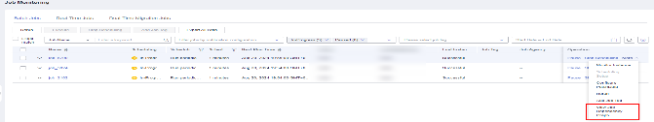  - Check whether the dependent jobs are correctly displayed in the job dependency graph.
Expected Result | The job dependency graph shows that the dependencies between jobs are the same as the actual dependencies.
Remarks | N/A
Test Result | N/A

Creating an MRS Connection
Objective | Verify that an MRS connection can be created.
Prerequisites | - The service is running properly.  - An MRS cluster and an agent (CDM cluster) are available.
Procedure | - Access the console, locate a workspace, click More in the Quick Starts column, and select Management Center.  - Click Create Data Connection and select MRS Hive.  - On the displayed page, set the following parameters:  Name: Enter hive_test_001.  Description: Enter hive_test_001.  Tag: Leave it blank.  Applicable Modules: Retain the default settings.  Manual: Select Cluster Name Mode.  MRS Cluster Name: Select a preset MRS instance.  Agent: Select the preset CDM cluster.  Username: Enter the preset MRS username.  Password: Enter the preset MRS password.  Enable ldap: Keep it disabled.  - Click Test to check whether the MRS Hive connection is up.  - Click Save.
Expected Result | The MRS Hive connection is created and displayed in the data connection list.
Remarks | N/A
Test Result | N/A

Editing a Data Connection
Objective | Verify that a data connection can be edited.
Prerequisites | - The service is running properly.  - A data connection has been created.
Procedure | - Access the console, locate a workspace, click More in the Quick Starts column, and select Management Center.  - Locate an MRS Hive data connection and click Edit in the Operation column.  - On the displayed page, set the following parameters:  Name: Enter hive_test.  Description: Enter hive_test.  Tag: Leave it blank.  Applicable Modules: Retain the default settings.  Manual: Select Cluster Name Mode.  MRS Cluster Name: Select a preset MRS instance.  Agent: Select the preset CDM cluster.  Username: Enter the preset MRS username.  Password: Enter the preset MRS password.  Enable ldap: Keep it disabled.  - Click Test to check whether the edited MRS Hive connection is up.  - Click Save.
Expected Result | The edited connection is displayed in the data connection list.
Remarks | N/A
Test Result | N/A

Metadata, catalog, modeling, and lineage

Creating and Running a Collection Task
Objective | Verify that a task can be created for collecting data from GaussDB(DWS).
Prerequisites | - DLG and DWS are running properly.  - A DWS connection has been created.  - DWS test data is available.
Procedure | - Access the DataArts Catalog page, choose Metadata Collection > Collection Tasks from the left navigation pane, and click Create.  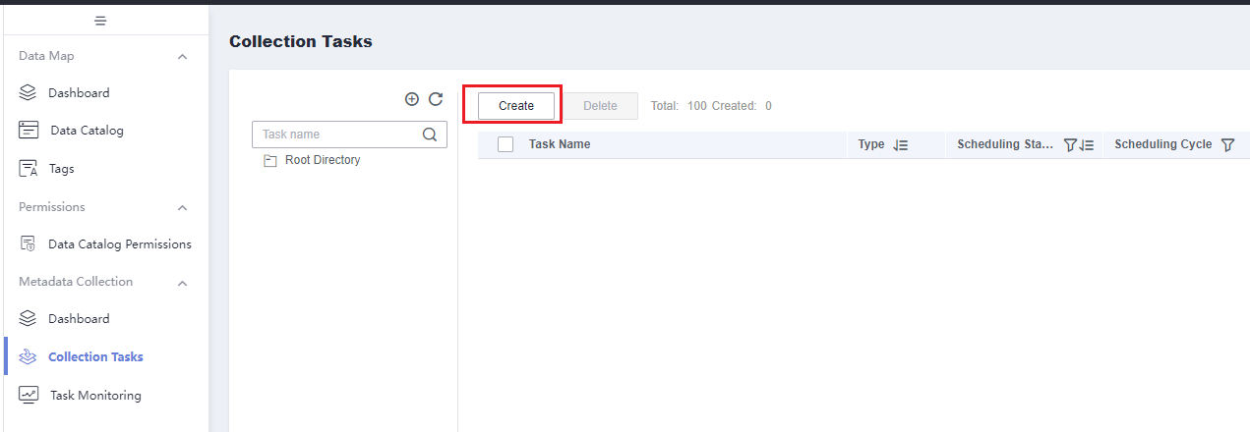  - Set the parameters as follows:  Enter a custom name in Name.  Retain the default value /Task name/ for Directory.  Select DWS for Data Connection Type.  Select dws for Data Connection.  Select postgres.dbadmin for Database and Schema.  Select t_trade_order and t_trade_order_xueyuan for Data Table.  Metadata Collection: Select Update and add metadata and Do not delete metadata.  Collect View Lineage: The default value is No.  (Optional) Data Summary: Select Sample data, first 100 rows.  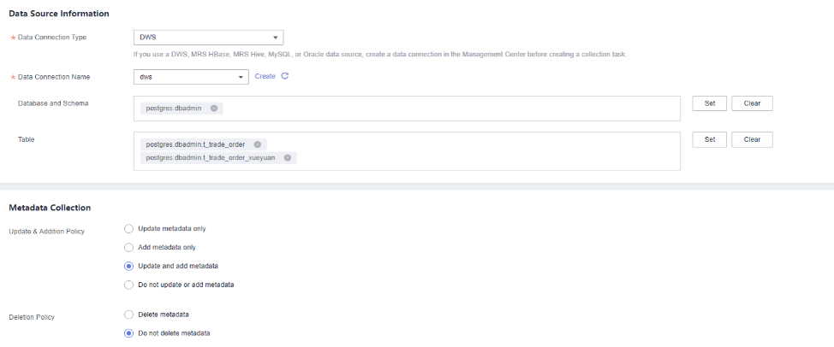  - Click Next.  - On the Schedule the Task page, set Mode to Once and click Submit.  - Access the Collection Tasks page, locate the task you just created and click Run to the right of it.  - View the status of the created collection task.  - After the task is complete, check whether the task status is successful. You can click the refresh button in the upper part to refresh the task status.
Expected Result | - The Create Collection Task page is displayed.  - The parameters are set successfully.  - The Scheduling Settings page is displayed.  - The Collection Tasks page is displayed.  - The Task Monitoring page is displayed.  - The task is in running state.  - The collection task is successfully executed.  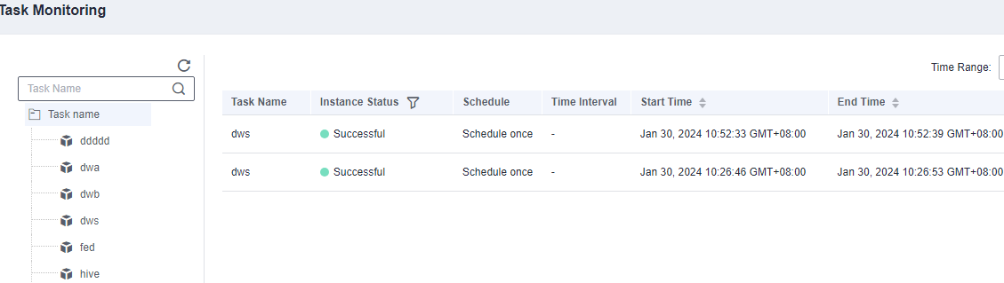
Remarks | N/A
Test Result | Pass

Viewing Collected Metadata
Objective | Verify that the data collected from GaussDB(DWS) databases and tables is correct.
Prerequisites | - DLG and DWS are running properly.  - A DWS connection has been created.  - A DWS metadata collection task is executed.
Procedure | - Access the DataArts Catalog page, choose Data Map > Catalog from the left navigation pane, and select the DWS connection under Data Connections. The collected metadata information is displayed on the right.  - Select Details to display metadata details.  - Select a data asset, click the pencil icon to the right of Tag to add the tags you want, and click OK.  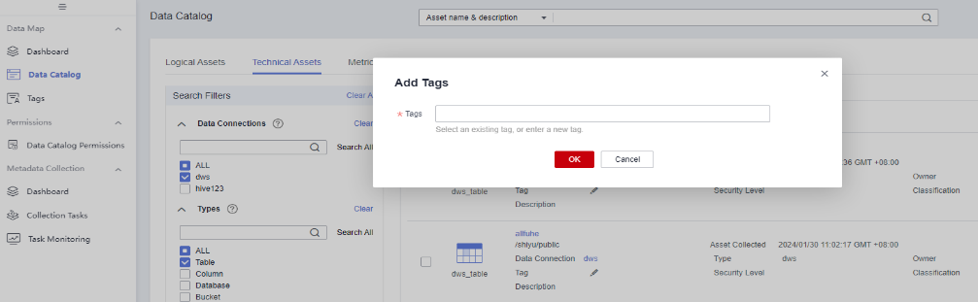  - In the left pane, select the created tag. (If no tag is found, refresh the page.)  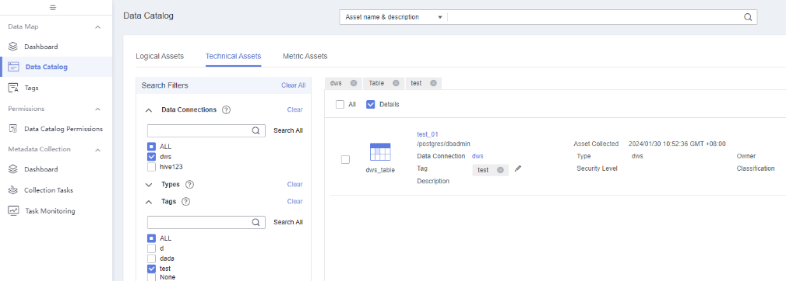
Expected Result | - The collected metadata is correctly displayed.  - The metadata details are correctly displayed.  - The tag is added.  - Only metadata with the tag is displayed on the right pane.
Remarks | N/A
Test Result | N/A

Generating a Lineage
Objective | Verify that a lineage can be generated for GaussDB(DWS) data.
Prerequisites | - DLG and DWS are running properly.  - A DWS connection has been created.  - A DWS metadata collection task is executed.
Procedure | - Access the DataArts Factory page, and choose Data Development > Develop Job from the left navigation pane.  - Right-click Jobs and choose Create Job. In the dialog box displayed, enter a job name, for example, dws_jod, retain the default settings for other parameters, and click OK.  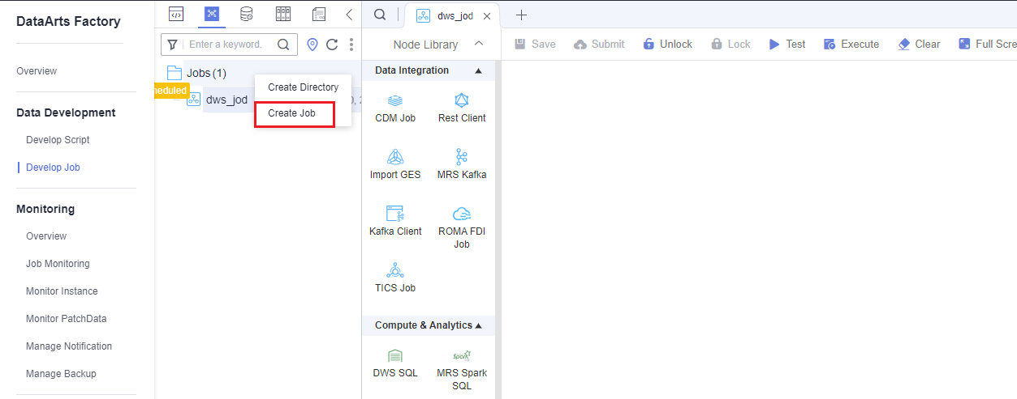  - Drag a DWS SQL node to the canvas.  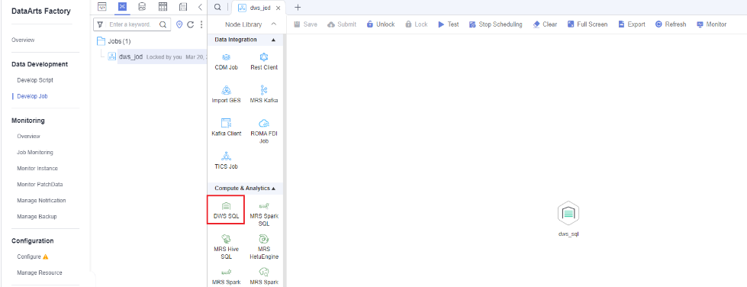  - Double-click the DWS SQL node and set the parameters as follows:  - Set Node Name to dws_sql.  - Set SQL or Script to SQL statement.  - SQL Statement: Enter INSERT INTO t_trade_order_xueyuan SELECT * FROM t_trade_order; and click OK.  - Set Data Connection to dws. Select a connection that has been created during connection management.  - Set Database to postgres, which is a DWS database name.  - Leave Dirty Data Table unspecified. If dirty data is generated, enter the name of the dirty data table.  - Leave Matching Rule unspecified. Dirty data will be filtered based on the matching rule.  - Leave Failure Matching Value unspecified. When the matched content equals the set value, the node fails to be executed.  - Click Save and then Submit  - Select This version will be executed when you click Execute. and click OK. Click Execute and go to the Job Monitoring page. After the job is executed, view the execution result.  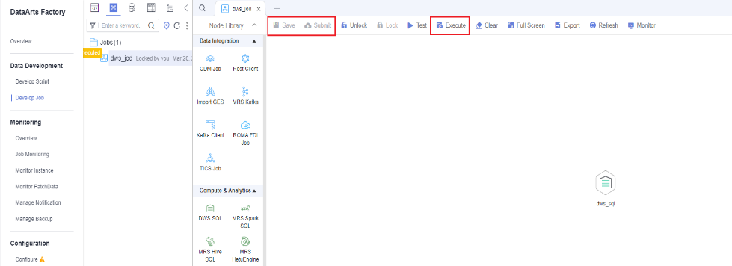  - Access the DataArts Catalog page, choose Data Map > Catalog, select DWS under Data Connections, and select Table under Types.  - Click the t_trade_order table on the right. On the table details page displayed, click Lineage.
Expected Result | - The Develop Job page is displayed.  - The job is created.  - The node is created.  - The parameters are set.  - The Submit New Version dialog box is displayed.  - The job is saved, submitted, and executed successfully. The job execution result is successful on the Job Monitoring page.  - The table is displayed in the right pane.  - The lineage of the t_trade_order table is accessible.
Remarks | N/A
Test Result

Creating a Data Warehouse Layer and a Model
Objective | Verify that a data warehouse layer and a model can be created
Prerequisites | DLG is running properly.
Procedure | - On the DataArts Architecture console, choose Data Warehouse Layer in the navigation pane on the left, click Create in the right pane, and select Add to front. In the displayed dialog box, set the following parameters:  - Layer Name: Enter a custom name, for example, THIRD_NF.  - Layer Type: Select ER modeling.  - Description: Enter a description. This parameter can be left blank.  - Click OK.  - At the created data warehouse layer, click Create and set the following parameters:  - Model Name: Enter a custom name, for example, ER_Modeling.  - Data Connection Type: Select DWS.  - Data Warehouse Layer: Select THIRD_NF.  - Prefix: Enter a prefix. This parameter can be left blank.  - Description: Enter a description. This parameter can be left blank.  - Click OK.
Expected Result | - The parameters are successfully set.  - The data warehouse layer is created.  - The parameters are successfully set.  - The model is created.
Remarks | N/A
Test Result | N/A

Creating, Publishing, Exporting, Deleting, and Importing a Fact Table
Objective | Verify that a summary table can be created, published, exported, imported, and deleted.
Prerequisites | - The current user has been added as a reviewer.  - A dimension has been published.  - A dimension table has been published.  - DLG and DWS are running properly.  - A DWS connection has been created.  - DWS test data is available.  - Subjects have been published.
Procedure | - Access the DataArts Architecture page, choose Models > Dimensional Modeling from the left navigation pane, and click the Fact Tables tab. On the page displayed, click Create.  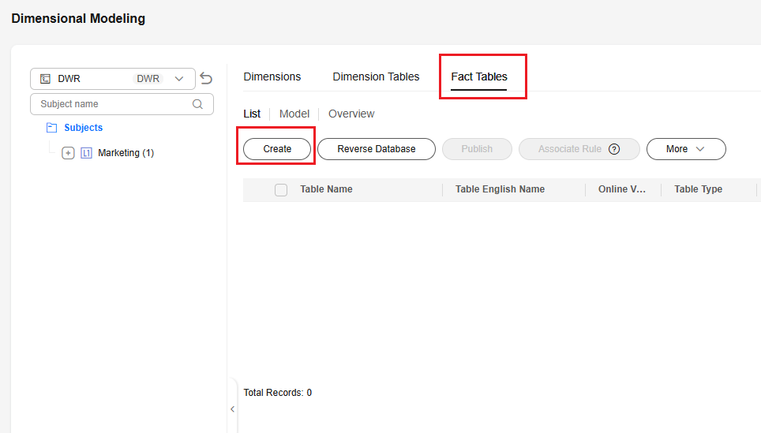  - On the displayed page, set the following parameters:  - Select marketing >marketing > store for Subject.  - Set Table Name to dwsTrade.  - Set Table English Name to fact_dwsTrade.  - Select an IAM tenant account or member account, or enter one for Owner.  - Select DWS for Data Connection Type.  - Select dws for Data Connection.  - Select postgres for Database.  - Select dbadmin for Schema.  - Select DWS_ROW for Table Type.  - Select NO for Compression Level.  - Description: Enter a description.  - In the Table Fields area, click Create and select Dimension from the drop-down list. In the dialog box displayed, select the created dimension and click OK. The dimension fields are added to the list.  - In the Table Fields area, click Create, select Measure from the drop-down list, and enter the field name and data type.  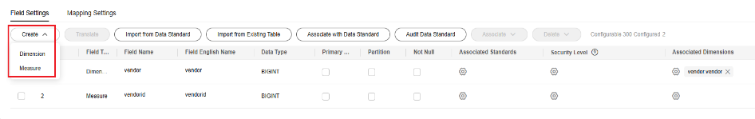  - Set the other parameters, and click Publish.  - In the dialog box displayed, select multiple reviewers and click OK.  - Log in to the system using the account of each selected reviewer, choose Review Center in the navigation pane on the left, click Pending Review, select the objects to be reviewed, and click Review. On the displayed page, click Approve, enter review comments, and click OK.  - In the left navigation pane, choose Dimensional Modeling. In the right pane, select a fact table, click More, and select Export.  - In the fact table list, locate a table you want to suspend, and choose More > Suspend in the Operation column. In the dialog box displayed, select Auto-review and click OK.  - In the fact table list, select the fact table you want to delete, choose More > Delete above the table list. In the dialog box displayed, confirm the fact table information, and click OK. Only suspended fact tables can be deleted.  - Click More and select Import. In the displayed dialog box, select Yes for Update Existing Data, select the fact table exported in step 8, and click Upload. After the table is uploaded, click Close.  - In the fact table list, locate a draft fact table, and click Publish in the Operation column.
Expected Result | - The Create Fact Table page is displayed.  - The parameters are successfully set.  - The dimension is added.  - The measure is added.  - The dialog box for publishing the fact table is displayed.  - The fact table is in publishing review state.  - After all reviewers approve the request, the fact table status changes to published.  - The fact table is exported, and information of the exported file is consistent with that of the fact table.  - The fact table is successfully suspended, and its status changes to suspended.  - The fact table is deleted.  - The fact table is imported, and the information of the imported fact table is the same as that of the imported file.  - The fact table is published, and its status changes to published.
Remarks | N/A
Test Result | N/A

Synchronizing Data Collected in DataArts Catalog to Data Map
Objective | Verify that the data collected in DataArts Catalog can be synchronized to Data Map.
Prerequisites | - DLG and DWS are running properly.  - A DWS connection has been created.  - DWS test data is available.  - Access the DataArts Catalog page, choose Metadata Collection > Collection Tasks from the left navigation pane, and click Create.  - Set the parameters as follows.  Enter a custom name for Task Name.  Retain the default value /Task name/ for Directory.  Select DWS for Data Connection Type.  Select dws for Data Connection Name.  Select postgres.dbadmin for Database and Schema.  Select t_trade_order and t_trade_order_xueyuan for Table.  Metadata Collection: Select Update and add metadata and Do not delete metadata.  Collect View Lineage: The default value is No.  (Optional) Data Summary: Select Sample data, first 100 rows.  - Click Next. On the Scheduling Settings page, set Schedule to Once and click Submit.  - Locate the task you just created and click Run in the Operation column.  - The task is executed successfully.
Procedure | - Access the Data Map console and choose Data Search from the navigation pane. Enter a DWS table name and search for it.  - In the displayed result, click the table name to go to the table details page.  - Click the Field Information, Data Preview, and Change tabs to view data.  - Click Followed. In the displayed dialog box, set and click OK.
Expected Result | - The DWS table is displayed in the search result.  - The DWS table information is displayed.  - Data is properly displayed on the Field Information, Data Preview, and Change pages.  - The operation is successful.
Remarks | create table IF NOT EXISTS t_trade_order(num int,sno varchar(10),name VARCHAR(10));create table IF NOT EXISTS t_trade_order_xueyuan(num int,sno varchar(10),name VARCHAR(10));
Test Result | N/A

Governance and Security

Creating a Data Catalog Permission
Objective | Verify that a data catalog permission can be created.
Prerequisites | - Tables have been collected in the data catalog, and the test tag has been added to some metadata.  - Tags are available on the Tags page.
Procedure | - Access the DataArts Catalog page, choose Permissions > Data Catalog Permissions, and click Create.  - Enter a rule name, for example, test.  - Select Tag for Type.  - Select a tag for Scopes, for example, test.  - Select the current user for Users (you can obtain the username from the upper right corner of the page).  - Validate: This function is enabled by default.  - (Optional) Enter a description.  - Click OK.  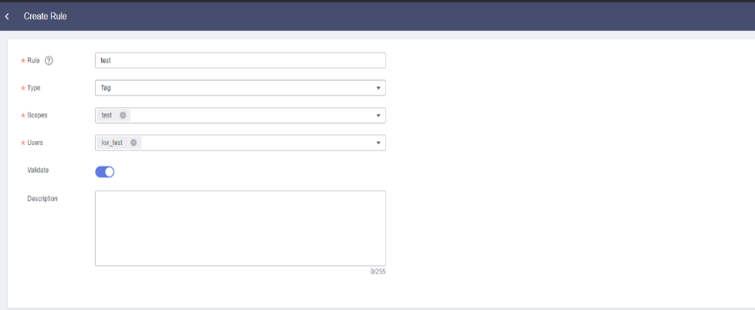
Expected Result | - The Create Rule page is displayed.  - The parameter is set.  - The type is selected.  - The scope is selected.  - The user is selected.  - The option is enabled.  - The parameter is set.  - The data catalog permission is created. Only data with the test tag is displayed in the data catalog.
Remarks | N/A
Test Result | N/A

Configuring the Data Security Administrator
Objective | Verify that the data security administrator can be configured.
Prerequisites | - Data Security is running properly.  - A user with the DataArts Studio Administrator permission has been created.
Procedure | - Log in to the DataArts Security console as DataArts Studio Administrator and choose Dashboard in the left navigation pane.  - Click the edit button next to the security administrator on top of the page, set the data security administrator, and save the settings.  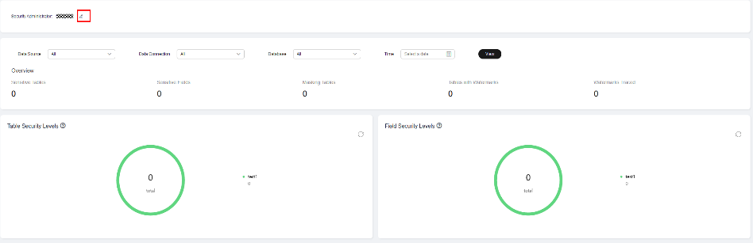
Expected Result | - The information on the Dashboard page is correct.  - The data security administrator is successfully set.
Remarks | N/A
Test Result | N/A

Creating a Sensitive Data Discovery Task
Objective | Verify that a sensitive data discovery task can be created.
Prerequisites | - Data Security is running properly.  - An identification rule using a specified template, for example, Mobile_Number, has been created.  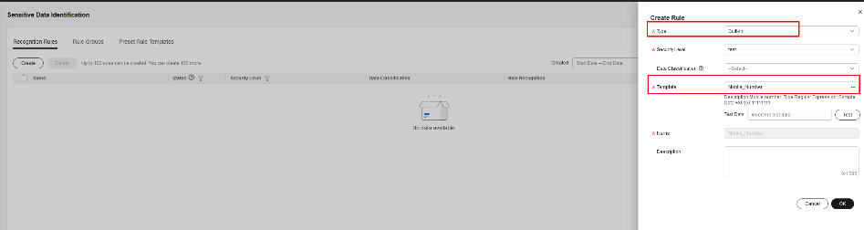  - A rule group that contains the identification rule created in the previous step has been created.  - A Hive data connection (proxy mode) has been created, and the MRS cluster where Hive resides is a security cluster with Kerberos authentication enabled.  - A Hive table has been created, and data has been configured for the table in DataArts Factory. The following are examples:  create table hive_samples(id int,name string,tel string);  INSERT INTO hive_samples VALUES(1,'aaa','13655545555');  INSERT INTO hive_samples VALUES(2,'bbb','13655545555');  INSERT INTO hive_samples VALUES(3,'ccc','13655545555');  - Metadata has been collected from the tables where sensitive data is to be detected through DataArts Catalog.
Procedure | - Log in to the DataArts Security console as the data security administrator and choose Sensitive Data Identification > Sensitive Data Discovery.  - Click Create.  Task and Task Description: Enter the task name and description.  Data Source: Select MRS Hive.  Data Connection: Select the Hive data connection.  Database and Data Table: Select a single database and data table.  Recognize Rule Group: Select the available rule group.  Retain the default values for other parameters.  - Select Once for Repeat.  - Click Submit.  - Click Run to the right of the task.  - In the left navigation pane, choose Sensitive Data Identification > Sensitive Data Distribution and check the distribution of sensitive data.  - Click the Manual Recovery tab.  - Locate the corresponding data and click OK in the Operation column.  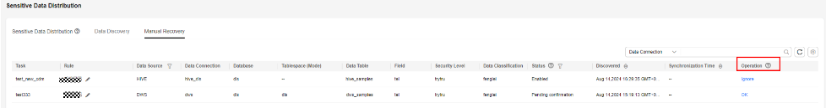
Expected Result | - The Sensitive Data Discovery page is correctly displayed.  - The parameters are set successfully.  - Repeat is set to Once.  - The task is created.  - The task is executed.  - The information displayed on the Sensitive Data Distribution page is correct and meets the expectation.  - The Manual Recovery page is displayed.  - The confirmation is successful, and the rule status is Valid.
Remarks | N/A
Test Result | N/A

Creating a Static Masking Policy
Objective | Verify that a static masking policy can be created.
Prerequisites | - Data Security is running properly.  - A recognition rule has been created.
Procedure | - Log in to the DataArts Security console as the data security administrator and choose Privacy Protection > Masking Policies > Static Masking Policies.  - Click Create.  Set the following parameters:  Policy Name: Enter a policy name.  Select a recognition rule.  Select an algorithm type.  Select a masking algorithm.  - Click OK.
Expected Result | - The Static Masking Policies page is properly displayed.  - The parameters are correctly configured.  - The static masking policy is created.
Remarks | N/A
Test Result | N/A

Creating a Data Watermark Embedding Task
Objective | Verify that a data watermark embedding task can be created.
Prerequisites | - Data Security is running properly.  - A Hive data connection (proxy mode) and a database table have been created, and the MRS cluster where Hive resides is a security cluster with Kerberos authentication enabled.
Procedure | - Log in to the DataArts Security console as the data security administrator and choose Privacy Protection > Data Watermark Embedding.  - Click Create.  Set the following parameters:  - Task and Description: Enter the task name and description.  - Watermark ID: Enter a watermark ID that meets the verification rule.  - Error Correction Level: Select 1.  - Watermark Version: Select V1.  Click Next.  Configure Source Settings:  - Data Source Type: Select MRS Hive.  - Data Connection: Select the Hive data connection.  - Database and Source Table: Select the database and table into which the watermark is to be embedded.  - Watermark Embedding Bar: Select the embedding bar of the watermark.  - Dataset Scope: Select All.  Configure Target Database Settings.  - Data Source Type: Select MRS Hive.  - Data Connection: Select the Hive data connection.  - Database: Select the target database.  - Target Table: Enter a table name that meets the verification rule and click Test.  After the test is successful, click Next.  - Select Once for the scheduling mode.  - Click OK.  - Run the task.
Expected Result | The data watermark embedding task is created after 4 is performed.  The data watermark embedding task runs successfully after 5 is performed.
Remarks | N/A
Test Result | N/A

Data Quality and Observability

Creating a Custom Rule Template
Objective | Verify that a custom rule template can be created.
Prerequisites | DLG is running properly.
Procedure | - Access the Data Quality Control console, choose Quality Monitoring > Rule Templates from the left navigation pane, and click Create.  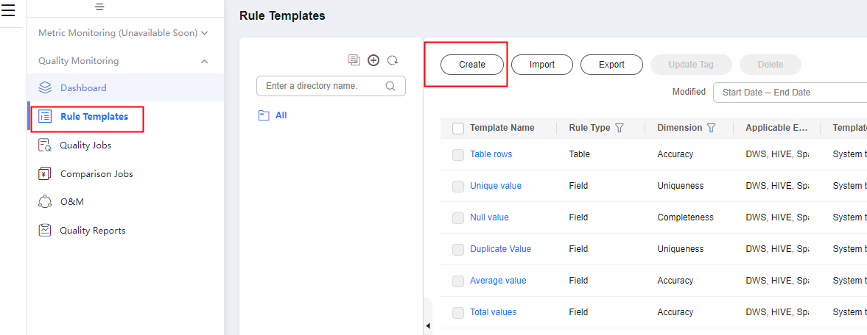  - On the page displayed, set the parameters as follows:  - Enter TotalNumber for Template Name.  - Select Accuracy for Dimension.  - Retain the default value /All/ for Owner Directory.  - Enter select count(${Column1}) from ${Schema_Table1} in the Define Relationship text box.  - Enter a description in the Output Description text box, for example, the total rows.  - Click Verify Semantics under the Output Description text box.  - Click OK.
Expected Result | - The operation is successful.  - The template parameters are set successfully.  - The content is entered in the Define Relationship text box successfully.  - The SQL result description is entered successfully.  - The semantic verification is successful.  - The template is saved.
Remarks | N/A
Test Result | N/A

Creating a One-Shot Quality Job
Objective | Verify that a one-shot quality job can be created and executed.
Prerequisites | - DLG and DWS are running properly.  - A DWS connection has been created.  - DWS test data is available.
Procedure | - Access the Data Quality Control page, choose Quality Monitoring > Quality Job from the left navigation pane, and click Create.  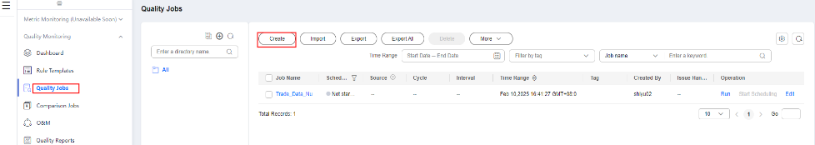  - Set Name to Trade_Data_NullValue, select Minor for Job Level, and click Next.  - On the Define Rule page, click the zoom-in button in the upper right corner of the subjob.  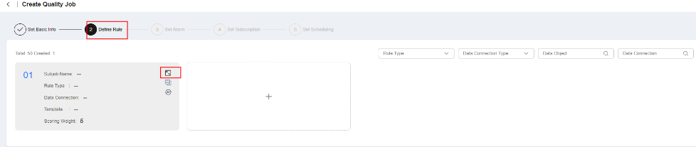  - Set the following parameters:  - Select Field rule for Rule Type.  - Select dws for Data Connection.  - Data Object: Select postgres for Database, dbadmin for Schema, t_trade_order for Table Name, and All for Field Name.  - Rule Template - Template: Select Null value.  - Object Scope - Scanning Scope: Select All or Partial.  - Alarm Condition - Alarm Expression: Enter ${1}==0.  - Click Next.  - Configure alarm information and click Next.  - Turn off the Notification switch and click Next.  - Select Schedule once and click Submit.  - Return to the Quality Job page, locate the job you just created in the job list, and click Run in the Operation column.
Expected Result | - The operation is successful.  - The quality job name is successfully entered and the other operations are successful.  - The job information is correctly displayed.  - Rule parameters are successfully set.  - The operation is successful.  - The alarm information is configured successfully.  - Notifications are disabled.  - The configuration of the one-shot quality job is saved.  - The quality job is successfully executed.
Remarks | N/A
Test Result | N/A

Creating a Periodic Quality Job
Objective | Verify that a periodic quality job can be created and scheduled.
Prerequisites | - DLG and DWS are running properly.  - A DWS connection has been created.  - DWS test data is available.
- Procedure | - Access the Data Quality Control page, choose Quality Monitoring > Quality Jobs from the left navigation pane, and click Create.  - Set Name to Trade_Data_NullValueForCycle, select Minor for Job Level, and click Next.  - On the Define Rule page, click the zoom-in button in the upper right corner of the subjob.  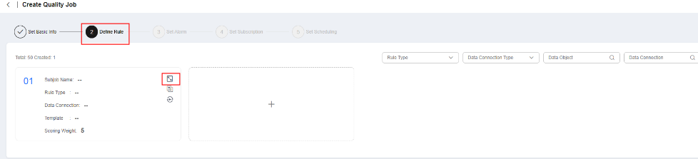  - Set the following parameters:  - Select Field rule for Rule Type.  - Select dws for Data Connection.  - Data Object: Select postgres for Database, dbadmin for Schema, t_trade_order for Table Name, and All for Field Name.  - Rule Template - Template: Select Null value.  - Object Scope - Scanning Scope: Select All or Partial.  - Alarm Condition - Alarm Expression: Enter ${1}==0.  - Click Next.  - Configure alarm information and click Next.  - Turn off the Notification switch and click Next.  - Select On schedule and set the parameters as follows:  - Select a valid period for Effective. Select the current day as the start day.  - Select minutes for Scheduling Cycle.  - Select 15 for Time Interval.  - Start scheduling the task from 00:00 to 23:59.  - Click Submit.  - Return to the Quality Jobs page, locate the job you just created, and click Start Schedule in the Operation column.  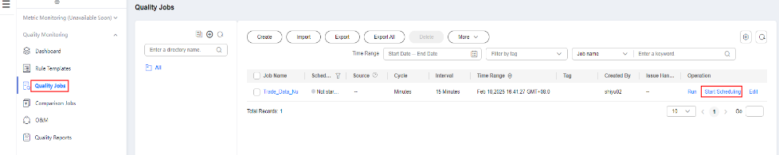
Expected Result | - The operation is successful.  - The quality job name is successfully entered and the other operations are successful.  - Rule parameters are successfully set.  - The operation is successful.  - The alarm information is configured successfully.  - Notifications are disabled.  - The periodic quality job is configured successfully.  - The periodic quality job is saved.  - Scheduling is started for the quality job.
Remarks | N/A
Test Result | N/A

Performing O&M Operations
Objective | Verify that you can rerun an instance, view run logs, and handle issues.
Prerequisites | - DLG is running properly.  - An alarming instance exists on the O&M Management page.
Procedure | - Access the Data Quality Control page, and choose Quality Monitoring > O&M Management from the left navigation pane.  - On the page displayed, locate an alarming instance and click Rerun in the Operation column.  - Click Details to the right of the selected instance to view its running result and logs.  - Click More and select Rectify to the right of the selected instance to rectify defects and view the processing history.  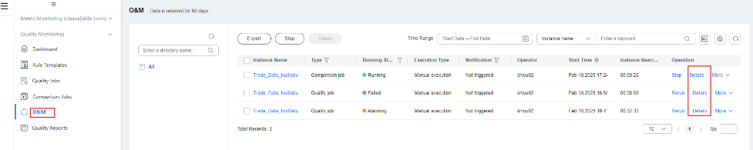
Expected Result | - There are O&M records on the O&M Management page.  - The instance is rerun immediately.  - Logs of the instance are displayed.  - The issues of the instance are handled.
Remarks | N/A
Test Result | N/A

Verifying a Quality Report
Objective | Verify that a technical report can be displayed on the Quality Report page.
Prerequisites | - DLG and DWS are running properly.  - A job that ran successfully exists. (Only jobs that ran before midnight can be monitored.)
Procedure | - Access the DataArts Quality page and choose Quality Monitoring > Quality Reports from the left navigation pane.  - Click the Technical Report tab.  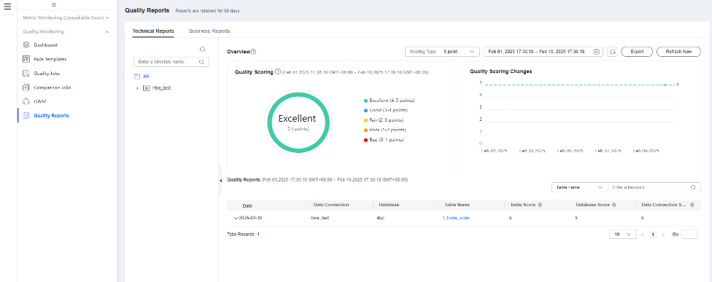
Expected Result | - The Quality Reports page is displayed.  - The Technical Reports page is displayed.
Remarks | N/A
Test Result | N/A

Data sharing and data services

Developing a GUI-based API
Objective | Verify that a GUI-based API can be developed. (The DWS data source is used as an example.)
Prerequisites | - DLG and DWS are running properly.  - A DLM incremental package has been created.  - A DWS connection has been created.  - DWS test data is available.  - API quota for DataArts DataService Exclusive has been allocated.  - A reviewer is available.
Procedure | - Access the DataArts DataService page and choose Exclusive. Choose API Development > APIs from the left navigation pane.  - Click Create and set the parameters as follows:  - Set API to getTaxiTripDataByID.  - Set API Catalog based on project requirements.  - Set Request Path to /TaxiTripData01.  - Select HTTPS for Parameter Protocol.  - Select GET for Request Mode.  - Select a reviewer for Reviewer.  - Select App authentication for Security Authentication.  - Click Next and set the parameters as follows:  - Set Data Acquisition Method to GUI based.  - Select DWS for Data Source.  - Select dws for Data Connection.  - Select postgres for Database.  - Select dbadmin.t_trade_order for Data Table.  - Parameter Settings: Click Add, select Response Parameter, and select all parameters.  - Click Next.  - In the Clusters area, select the cluster you want to test and click Debug.  - After debugging the API, the request and response data is displayed on the right. Click OK.  - Return to the APIs page. Locate the API you just created and choose More > Publish in the Operation column. In the dialog box displayed, confirm the information, and click OK.
Expected Result | - The APIs page is displayed.  - The API parameters are set successfully.  - The API data source information is configured successfully.  - The Test page is displayed.  - The API test is successful.  - The API is created.  - The API is published.
Remarks | N/A
Test Result | Pass

Developing a Script API
Objective | Verify that a script API can be developed. (The DWS data source is used as an example.)
Prerequisites | - DLG and DWS are running properly.  - A DLM incremental package has been created.  - A DWS connection has been created.  - DWS test data is available.  - API quota for DataArts DataService Exclusive has been allocated.
Procedure | - Access the DataArts DataService page and choose Exclusive. Choose API Development > APIs from the left navigation pane.  - Click Create and set the parameters as follows:  - Set API to getTaxiTripDataByIDTwo.  - Set API Catalog based on project requirements.  - Set Request Path to /TaxiTripData02.  - Select HTTPS for Protocol.  - Select GET for Request Mode.  - Select a reviewer for Reviewer.  - Select App authentication for Security Authentication.  - Click Next and set the parameters as follows:  - Select Script for Data Acquisition Method.  - Select DWS for Data Source.  - Select dws for Data Connection.  - Select postgres for Database.  - Enter select * from dbadmin.t_trade_order in the Script for Obtaining Values text box.  - Click Next.  - In the Clusters area, select the cluster you want to test and click Debug.  - After debugging the API, the request and response data is displayed on the right. Click OK.  - Return to the APIs page. Locate the API you just created and choose More > Publish to the right of it. In the dialog box displayed, confirm the information, and click OK.
Expected Result | - The APIs page is displayed.  - The API parameters are set successfully.  - The API data source information is configured successfully.  - The Test page is displayed.  - The API test is successful.  - The API is created.  - The API is published.
Remarks | N/A
Test Result | Pass

Calling APIs
Objective | Verify that an API can be called. (The DWS data source is used as an example.)
Prerequisites | - DLG and DWS are running properly.  - A DWS connection has been created.  - An API that uses application authentication has been created and published.  - Java, Python, and C projects can run (this test case uses Java as an example).  - You have created a DataArts DataService cluster.
Procedure | - Create an application.  - Access the DataArts DataService page and choose Exclusive. Choose API Calling > Apps from the left navigation pane. On the page displayed, click Create. In the dialog box displayed, set the following parameters:  Set Name to a custom value.  Set Type to APP.  - Click OK.  - Return to the Apps page, and click the name of the application you just created to obtain the AppKey and AppSecret.  - Authorize a published API.  - Access the APIs page. Click the name of a published API to enter the API details page.  - Choose Authorization > Authorize. In the dialog box displayed, set the parameters as follows:  In Expired, set the date when the authorization expires.  Select a value for Cluster.  Select an authorized application from App.  - Click OK.  - Call the API to obtain the DWS table data.  - Access the Data Lake Mall page, and click Exclusive Edition. Choose API Calling > SDKs from the left navigation pane. Download the SDK you need. For example, to download the Java SDK, click Download Java SDK and decompress the downloaded package.  - Import the decompressed file to the code project, go to the ApiGateway-java-sdk-xxx\src\com\apig\sdk\demo directory, and modify the following parameters in the Main.java file:  request.setKey: Change it to the AppKey of the app.  request.setSecret: Change it to the AppSecret of the app.  request.setMethod: Change it to the request method for accessing the API.  request.setUrl: Change it to the private or public IP address for accessing API details.  - After the configuration is complete, run the program to check whether the returned data is correct.
Expected Result | - The application is created.  - The API is authorized.  - The API is called, and the returned calling result is correct.
Remarks | N/A
Test Result | Pass

Exporting and Importing APIs
Objective | Verify that APIs can be imported and exported. (The DWS data source is used as an example.)
Prerequisites | An API has been created.
Procedure | - Access the DataArts DataService page and choose Exclusive. In the left navigation pane, choose API Development > APIs. On the displayed page, select APIs, click More above the list, and select Export.  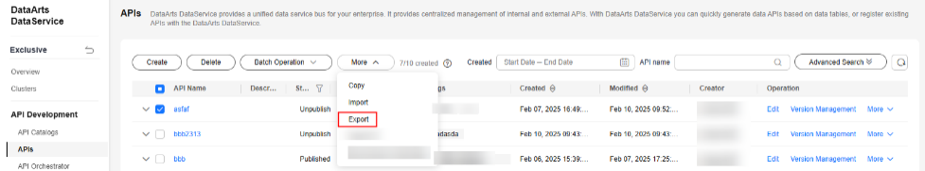  - In the displayed dialog box, click OK to export the APIs to an Excel file.  - On the APIs page, choose More > Import. Click Select to select an Excel file and click Import.
Expected Result | - The APIs page is displayed.  - The APIs are exported.  - The APIs are imported successfully.
Remarks | When importing APIs, set Overwrite as needed.
Test Result | Pass

Editing an API
Objective | Verify that an API can be edited. (The DWS data source and a GUI-based API are used as examples.)
Prerequisites | - DLG and DWS are running properly.  - A DataArts DataService incremental package has been created.  - A DWS connection has been created.  - DWS test data is available.  - API quota for DataArts DataService Exclusive has been allocated.  - An API that has not been published or has been suspended is available.
Procedure | - Access the DataArts DataService page and choose Exclusive. Choose API Development > APIs from the left navigation pane.  - Locate an API and click Edit. The following data is automatically populated. Set the parameters as follows:  - Set API to getTaxiTripDataByID.  - Set API Catalog based on project requirements.  - Set Request Path to /TaxiTripData01.  - Select HTTPS for Protocol.  - Select GET for Request Mode.  - Select a reviewer for Reviewer.  - Select App authentication for Security Authentication.  - Click Next. The following data is automatically populated. Set the parameters as follows:  - Set Data Acquisition Method to GUI based.  - Select DWS for Data Source.  - Select dws for Data Connection.  - Select postgres for Database.  - Select dbadmin.t_trade_order for Fact Table.  - Parameter Settings: Click Add, select Response Parameter, and select all parameters.  - Click Next.  - In the Clusters area, select the cluster you want to test and click Debug.  - After debugging the API, the request and response data is displayed on the right. Click OK.  - Return to the APIs page. Locate the API you just edited and choose More > Publish in the Operation column. In the dialog box displayed, confirm the information, and click OK.
Expected Result | - The APIs page is displayed.  - The API parameters are set successfully.  - The API data source information is configured successfully.  - The Test page is displayed.  - The API test is successful.  - The API is edited.  - The API is published.
Remarks | N/A
Test Result | N/A

Filtering APIs by Authorization Status
Objective | Verify that APIs can be filtered by authorization status on the APIs page. (The DWS data source is used as an example.)
Prerequisites | - DLG and DWS are running properly.  - A DataArts DataService Exclusive incremental package has been created.  - A DWS connection has been created.  - DWS test data is available.  - API quota for DataArts DataService Exclusive has been allocated.  - The account status is normal.  - There are unauthorized APIs, authorized APIs, and APIs that do not need to be authorized.
Procedure | - Access the DataArts DataService console and choose Exclusive > API Development > APIs from the left navigation pane.  - In the API list, click the filter button in the Authorization Status column and select No Authorization Required.  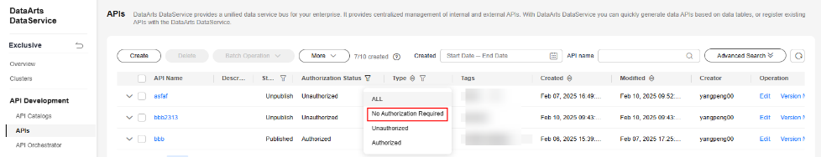  - In the API list, click the filter button in the Authorization Status column and select Unauthorized.  - In the API list, click the filter button in the Authorization Status column and select Unauthorized.
Expected Result | - The APIs page is displayed.  - The APIs that do not need to be authorized are displayed.  - Unauthorized APIs are displayed.  - Authorized APIs are displayed.
Remarks | Three types of API statuses are available: No Authorization Required, Unauthorized, and Authorized.  No Authorization Required: APIs in DataArts DataService Exclusive with no authentication do not require authorization.  Authorized: APIs in DataArts DataService Exclusive that use IAM authentication or app authentication. There are authorization records. The authorization status is bound with an app, pending unsubscription review, or pending renewal review, and the authorization period is within the validity period.  Unauthorized: scenarios except the preceding two scenarios
Test Result | N/A

Exporting and Importing APIs with Tags
Objective | Verify that APIs with tags can be imported and exported. (The DWS data source is used as an example.)
Prerequisites | APIs with tags are available.
Procedure | - Access the DataArts DataService page and choose Exclusive. In the left navigation pane, choose API Development > APIs. On the displayed page, select APIs, click More above the list, and select Export.  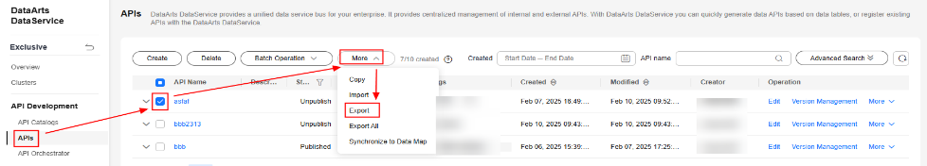  - In the displayed dialog box, click OK to export the APIs to an Excel file and view the API tags in the Excel file.  - Change the names of the API tags in the Excel file. On the APIs page, click More and select Import. On the displayed page, click Select next to Import File, select the local API file, and click Import. Then view the names of the API tags.
Expected Result | - The APIs are exported successfully.  - The Excel file contains tags.  - The APIs are imported successfully, and the names of the API tags have changed.
Remarks | N/A
Test Result | N/A

DataOps and Lifecycle Management

Testing a Job
Objective | Verify that a job can be tested.
Prerequisites | The data development function is normal.
Procedure | - On the Data Development page, choose Development > Develop Job. On the displayed page, double-click a job in the job directory.  - Click Test to view the job running result.
Expected Result | After Test is clicked, the job starts to be tested. The job running result is displayed. You can right-click the node to view the node run log.
Remarks | N/A
Test Result | N/A

Creating, Exporting, Deleting, and Importing a Process
Objective | Verify that a process can be created, exported, deleted, and imported.
Prerequisites | - DLG is running properly.  - In Configuration Center, the default process levels are used.
Procedure | - Access the DataArts Architecture page, choose Data Survey > Processes in the left navigation pane, and click Create in the right pane. In the displayed dialog box, set the parameters as follows:  - Process Name: Enter a custom name, for example, RG_test.  - Process Name(En): Enter a custom name, for example, RG_test.  - Owner: Select or enter an owner.  - Parent Process: Select the process path. Retain the default value.  - Click OK.  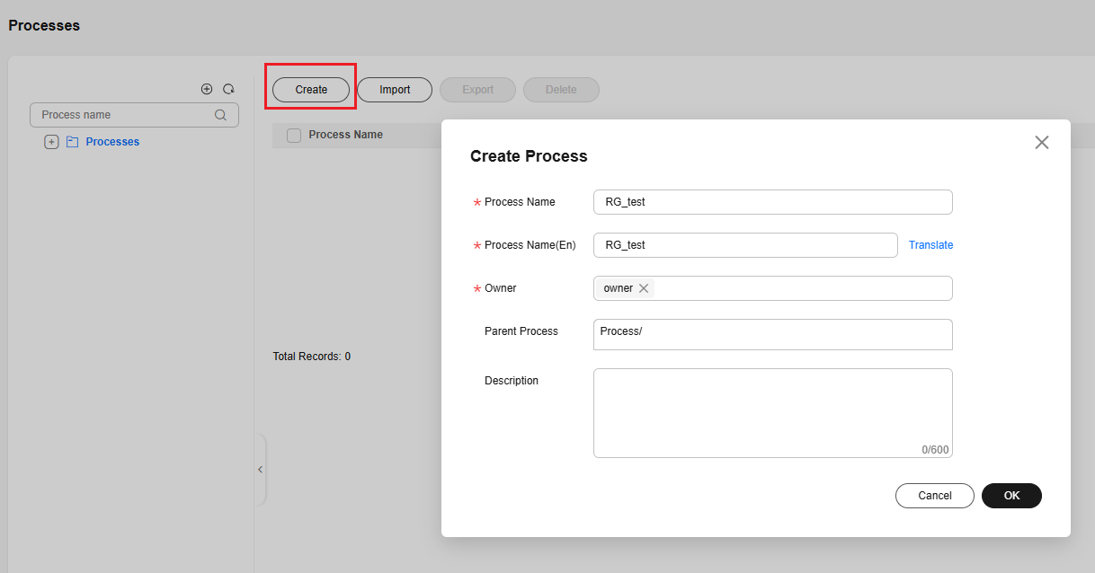  - Return to the Processes page, select the process you just created in the left pane, and click Create in the right pane. In the displayed dialog box, set the parameters as follows:  - Process Name: Enter a custom name, for example, RG_test001.  - Process Name(En): Enter a custom name, for example, RG_test001.  - Owner: Select or enter an owner for the process.  - Parent Process: Enter Process/RG_test.  - Description: Enter a description. This parameter can be left blank.  - Click OK.  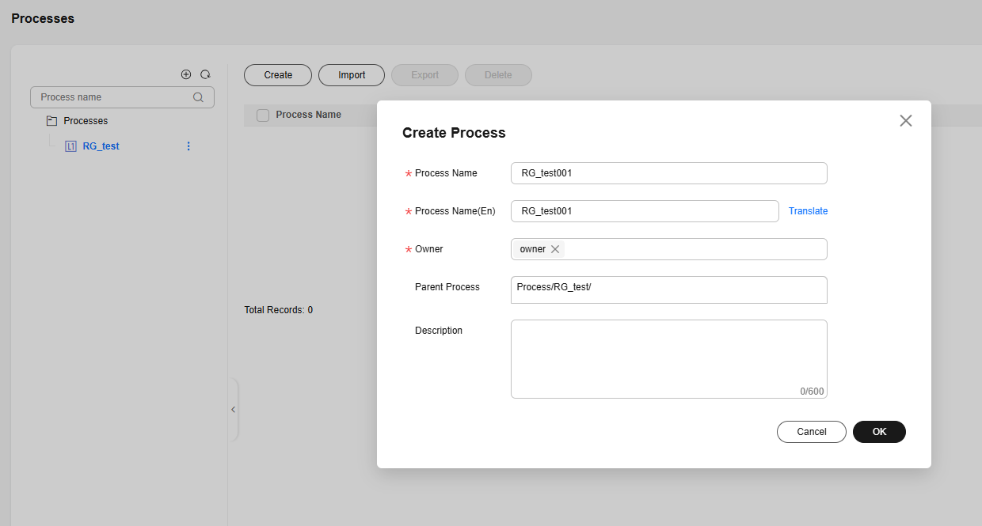  - Click Export above the process list to export all process information.  - Select the process you just created and click Delete above the process list to delete the process.  - Click Import. In the displayed dialog box, select Yes for Update Existing Data, select the process file exported in step 5, and click Upload. After the process is uploaded, click Close.  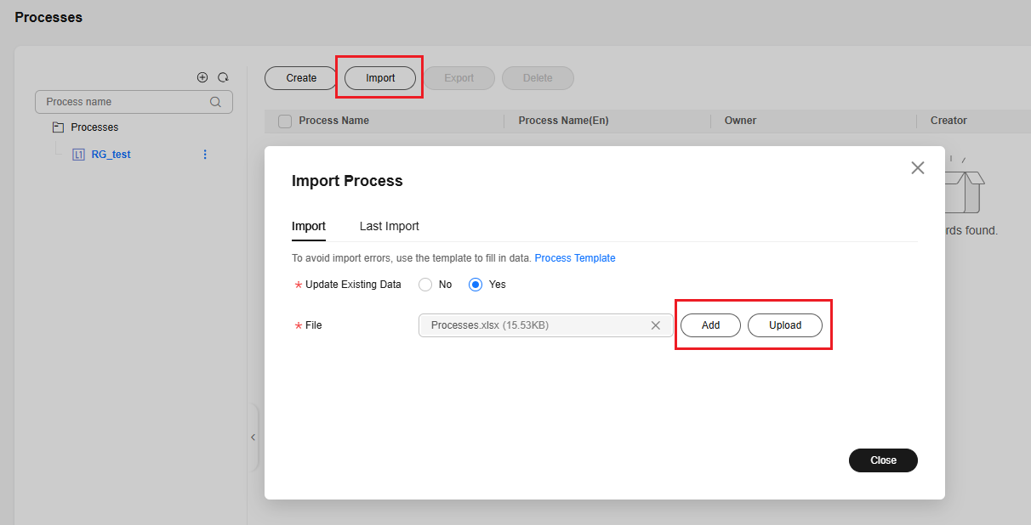
Expected Result | - The parameters are successfully set.  - The process is created.  - The parameters are successfully set.  - The process is created.  - The process is exported successfully, and the information in the exported file is consistent with that of the process.  - The process is deleted.  - The process is imported successfully, and the information of the imported process is the same as that in the imported file.
Remarks | N/A
Test Result | N/A

Creating a Data Source Export Task
Objective | Verify that a data source export task can be created.
Prerequisites | - The service is running properly.  - A data source is available.
Procedure | - Access the console, locate a workspace, click More in the Quick Starts column, and select Management Center.  - Choose Migrate Resources in the left navigation pane and click Create Export Task. In the displayed dialog box, set OBS Path and File Name.  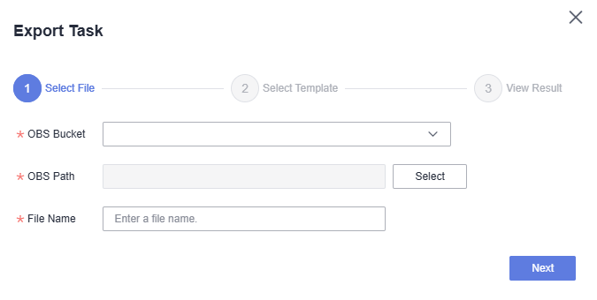  - Click Next and select the types of resources to export.  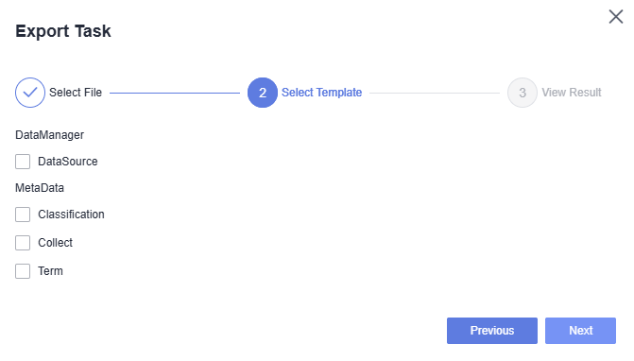  - Click Next and view the export result.  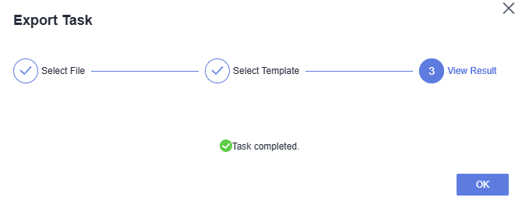  - Click OK.
Expected Result | The export task is created.
Remarks | N/A
Test Result | N/A

Resilience, Monitoring, and Resource Consumption

Creating a cdm.xlarge Incremental Package
Objective | Verify that a cdm.xlarge incremental package can be created.
Prerequisites | - The organization security administrator (tenant) has registered an account and can log in to the DataArts Studio console.  - The quota of the security administrator (user) is sufficient.  - The CDM service is running properly.  - A VPC, a subnet, and a security group have been created.
Procedure | - Log in to the DataArts Studio console and click Create Instance. On the displayed page, select a region and enterprise project, enter the instance name, and click Create Now.  - Locate the created DataArts Studio instance and click Access. On the displayed page, click the Workspaces tab and then Create Workspace. In the displayed dialog box, enter default for Name and set other parameters.  - Click Create under the created DataArts Studio instance.  - Select DataArts Migration for Package, default for Workspace, and cdm.xlarge for Instance Type. Select the created VPC, subnet, and security group, and set other parameters as required.  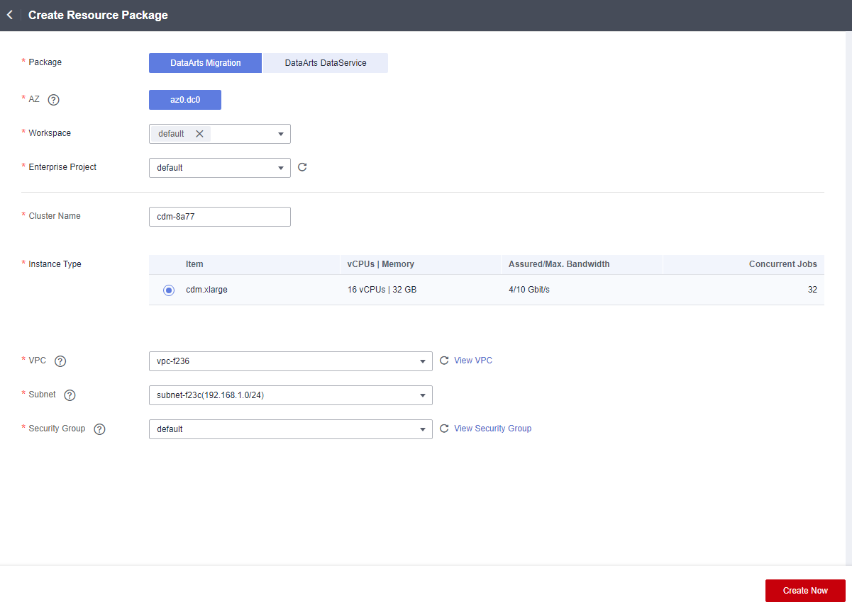  - Click Create Now, confirm the specifications, and click Submit. After the submission is successful, click Back to Instance List in the upper left corner.  - Click Access on the instance to enter the console. In the default workspace, click DataArts Migration to go to the Cluster Management page and view the creation progress.  - Check the creation result.
Expected Result | - The home page of the DataArts Studio console is displayed, and the instance is created.  - The workspace is created successfully.  - The Create Resource Package page is displayed.  - The specifications are selected.  - The instance list is displayed.  - The cluster management page is displayed, and the cluster creation progress is displayed.  - The cluster is created about 15 minutes later.
Remarks | Test duration: 15 minutes
Test Result | N/A

Viewing Monitoring Metrics of a Cluster
Objective | Verify that the monitoring metrics of a cluster can be viewed successfully.
Prerequisites | - The organization security administrator (tenant) has registered an account and can log in to the DataArts Studio console and access DataArts Migration.  - The security administrator (user) can log in to the DataArts Studio console and access DataArts Migration.  - The CDM service is running properly.  - There is at least one cluster in running state.
Procedure | - The Cluster Management page is displayed.  - In the row of a running cluster, choose More > View Metric.  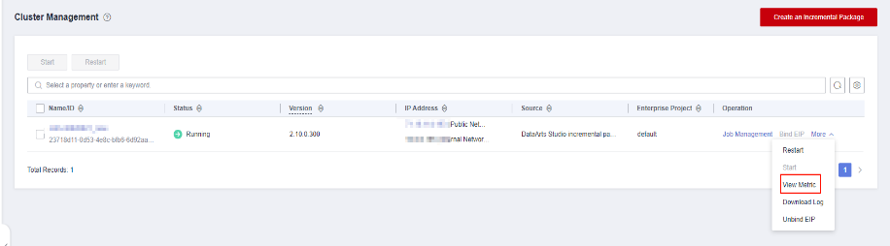  - Check whether the CDM cluster monitoring page is displayed.  - Check whether the resource usage of the cluster is displayed.
Expected Result | - The Cluster Management page is displayed.  - The View Metric operation functions properly.  - The CDM cluster monitoring page is properly displayed.  - The cluster resource usage is properly displayed.
Remarks | Test duration: 5 minutes
Test Result | N/A

Viewing Monitoring Overview
Objective | Verify that the monitoring overview can be viewed successfully.
Prerequisites | The data development function is normal.
Procedure | - Access the Data Development page, and choose Monitoring > Overview.  - Check whether the running status of the job instance meets the actual situation.
Expected Result | The overview function is normal. The scheduling overview of the job instances in the current day and last seven days is displayed. Abnormal jobs and execution duration are recorded.
Remarks | -
Test Result | -

Monitoring Real-Time Processing Jobs
Objective | Verify that real-time processing jobs can be monitored.
Prerequisites | The data development function is normal.
Procedure | - Access the Data Development page, and choose Monitoring > Monitor Job.  - On the Real-Time Job Monitoring tab page, view the execution frequency, result, and run log of each job.  - Click Start to start the real-time job.  - Click Stop to stop the real-time job.  - Select a running real-time job and click the job name to access the real-time job monitoring page.  - Stop and start the job.  - Check whether the input and output data of the node is correctly displayed. Click the node to check whether the information queried by the node is correctly displayed.
Expected Result | The real-time job monitoring is normal, the node information can be queried, and the Start and Stop operations are normal.
Remarks | -
Test Result | -

Monitoring Instances
Objective | Verify that instances can be monitored.
Prerequisites | The data development function is normal.
Procedure | - Access the Data Development page, and choose Monitoring > Monitor Instance.  - On the Monitor Instance page, view the instance information about the job and perform more operations on instances and node tasks as required. Select a job and perform the operations, such as stop, rerun, view the waiting job instance, continue, succeed, and view, on the job based on job status.
Expected Result | The operation buttons on the Real-Time Job Monitoring page are normal, and the job content on the historical scheduling page is correct.
Remarks | N/A
Test Result | N/A

